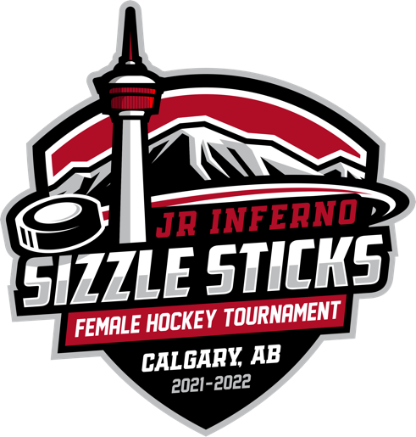

TOURNAMENT EXPRESSION OF INTEREST

U11 “Sizzle Sticks” Female Hockey Tournament
November 26-28, 2021 - East Calgary Twin Arenas, Calgary, Alberta
Hockey Calgary Sanction # 21-900083
Hockey Alberta Sanction # HA-21351755

Team Name:
Hockey Association:
Division, League: (i.e. U11 4, Central Alberta Hockey League)
Contact Info:
Name:
Team Role:
Email:
Phone:
Additional Information: (i.e. Reciprocals)

Send expressions of interest to: U11GHCtournament@gmail.com

